Smart Queue & Appointment Management System
CSC 2032 – Object Oriented Programming



Group Members :
AS20240479 M.P.G.D.Nimeshika
AS20240596 O.A.Thewarapperuma

GitHub repository link : https://github.com/Dilki30/smart-queue-system.git

Content
1. Introduction 1
2. Problem Statement 1
3. Objectives 1
3.1 Main Objective 1
3.2 Specific Objectives 1
4. Proposed Solution 2
5. Technologies Used 2
6. System Features 2
6.1 User Authentication 2
6.2 Dashboard 3
6.3 Appointment Booking 3
6.4 Queue Management 3
6.5 Ticket Generation 3
6.6 History 3
6.7 User Profile 4
6.8 Admin Authentication 4
7. Object-Oriented Programming Concepts 4
7.1 Encapsulation 4
7.2 Abstraction 4
7.3 Inheritance 5
7.4 Polymorphism 5
8. System Architecture 6
9. Database Design 6
9.1 User Table 6
9.2 Appointment Table 6
9.3 Queue Table 7
10. System Interfaces 7
11. Testing 13
12. Future Improvements 15
13. Conclusion 16
14. References 16

1. Introduction
Queue management has become a significant challenge in hospitals, banks, government offices, and other public service organizations. Traditional manual queue systems cause long waiting times, overcrowding, and poor customer satisfaction.
The Smart Queue Appointment System is a web-based application developed to digitalize queue management by allowing customers to reserve appointments online, receive queue numbers, monitor queue status, and view their appointment history.

2. Problem Statement
Many organizations still rely on manual token systems.
Problems include:
- Long waiting times
- Overcrowded waiting areas
- Customers unsure about their queue position
- Time wastage
- Difficult queue management
- No online booking system
- No appointment history

3. Objectives

3.1 Main Objective
Develop an online Smart Queue Appointment System using Object-Oriented Programming concepts.

3.2 Specific Objectives
- Allow users to register and login
- Book appointments online
- Generate queue tokens automatically
- Display live queue information
- Maintain appointment history
- Improve customer experience
- Reduce waiting time

4. Proposed Solution
The proposed system provides an online platform where customers can:
- Create an account
- Login securely
- Select a service
- Book appointments
- Receive queue numbers
- View live queue status
- Access booking history
- Manage their profile
Administrators can manage queues and appointments efficiently.

5. Technologies Used
Component | Technology
Frontend | HTML5
Styling | CSS3
Client-side | JavaScript
Backend | Node.js
Architecture | REST API
Data Storage | JSON File Database (Can be upgraded to MySQL)
Version Control | Git & GitHub

6. System Features

6.1 User Authentication
- User Registration
- User Login
- Logout
- Session Management

6.2 Dashboard
Displays
- User information
- Upcoming appointments
- Queue statistics
- Navigation panel

6.3 Appointment Booking
Users can
- Choose service
- Select appointment date
- Select appointment time
- Submit booking

6.4 Queue Management
System automatically
- Generates queue numbers
- Displays queue position
- Shows waiting status
- Updates queue progress

6.5 Ticket Generation
After booking
- Queue number generated
- Appointment details shown
- Booking confirmation displayed

6.6 History
Users can
- View previous bookings
- View completed appointments
- Track appointment records

6.7 User Profile
Users can update
- Name
- Email
- Password
- Personal information

6.8 Admin Authentication
Admin can view queue status and cancel appointments.

7. Object-Oriented Programming Concepts
The project follows Object-Oriented Programming principles.

7.1 Encapsulation
Sensitive user information is managed securely through classes and modules.
Example:
- User class
- Ticket Handler
- Authentication Handler

7.2 Abstraction
Complex backend operations are hidden from users.
Examples:
- Queue generation
- Authentication
- Booking process

7.3 Inheritance
Future versions can include:
User
↓
Customer
↓
Administrator
Both inherit common properties from the User class.

7.4 Polymorphism
Different service handlers perform booking differently.
Examples
- Hospital Handler
- Bank Handler
- Ticket Handler
Each processes requests uniquely while using a common structure.

8. System Architecture
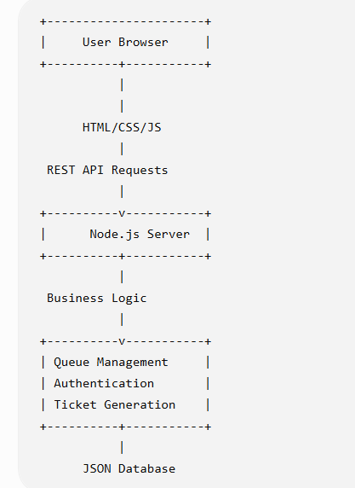

9. Database Design

9.1 User Table
Field | Type
UserID | Integer
Name | Varchar
Email | Varchar
Password | Varchar

9.2 Appointment Table
Field | Type
AppointmentID | Integer
UserID | Integer
Service | Varchar
Date | Date
Time | Time
QueueNumber | Integer
Status | Varchar

9.3 Queue Table
Field | Type
QueueID | Integer
QueueNumber | Integer
CurrentPosition | Integer
Status | Varchar

10. System Interfaces
The project contains the following pages:
- Login Page
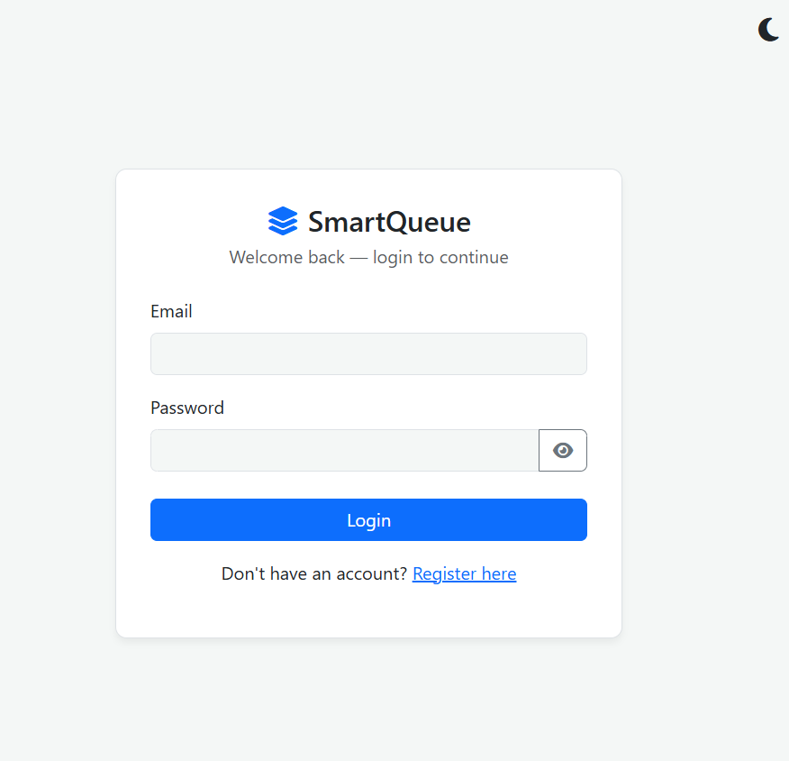
- Registration Page

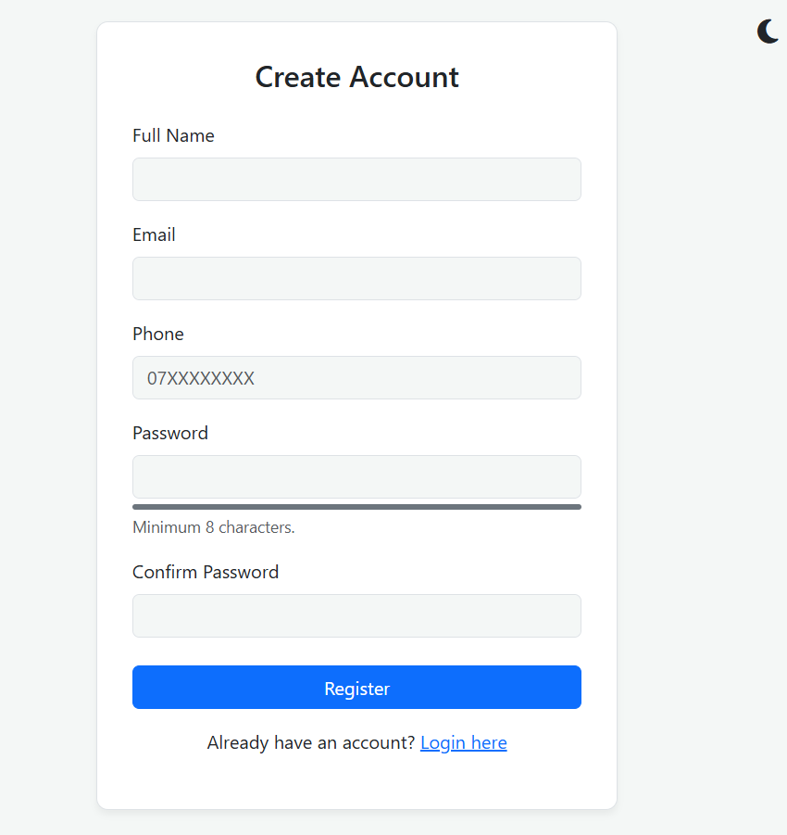

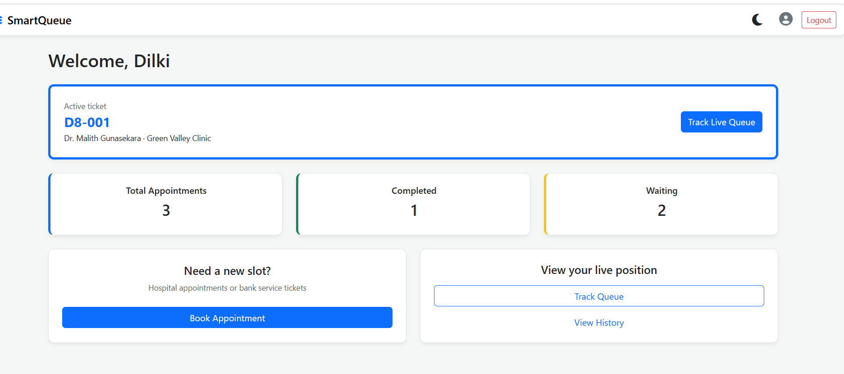
- Dashboard

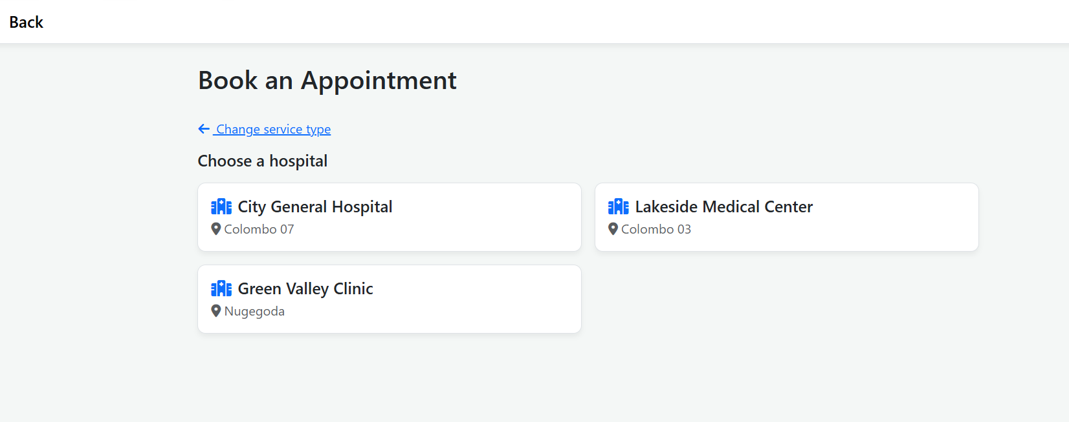
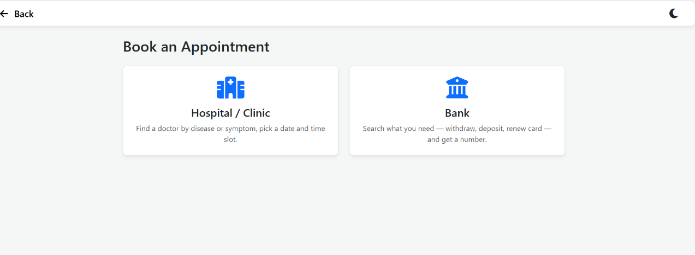
- Appointment Booking
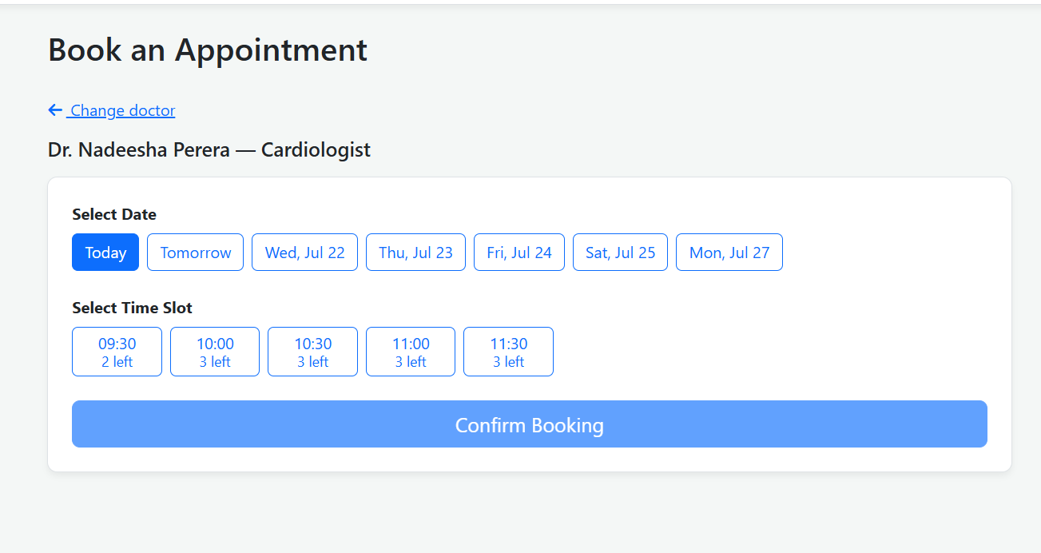

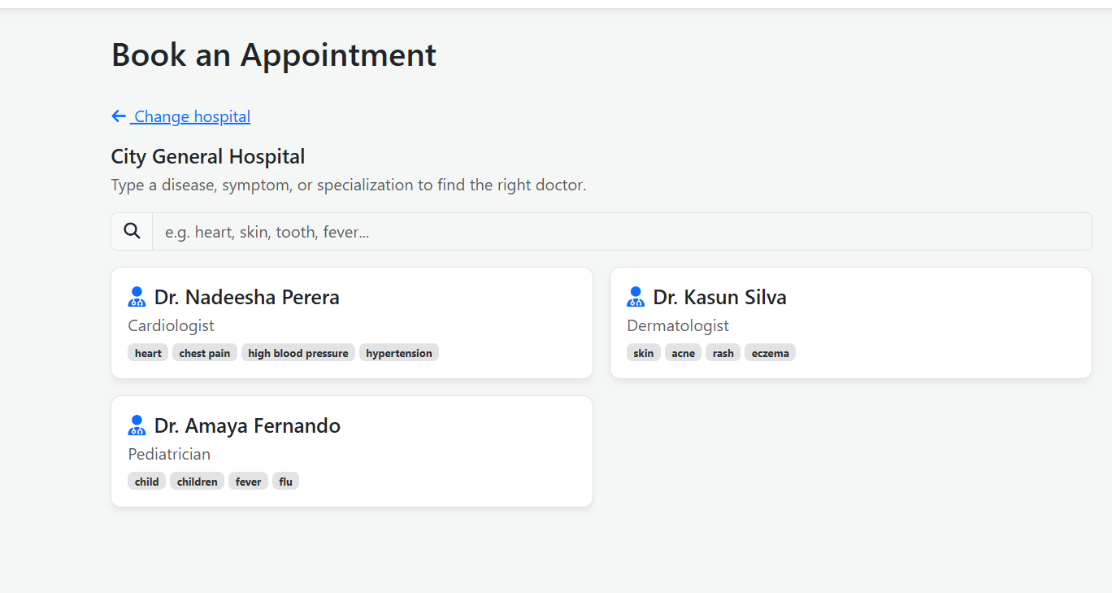

- Queue Status

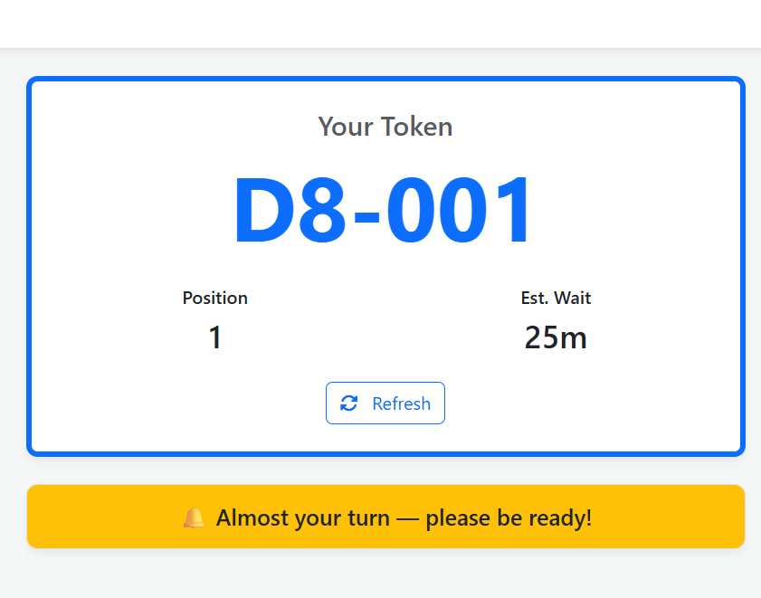

- Queue Ticket

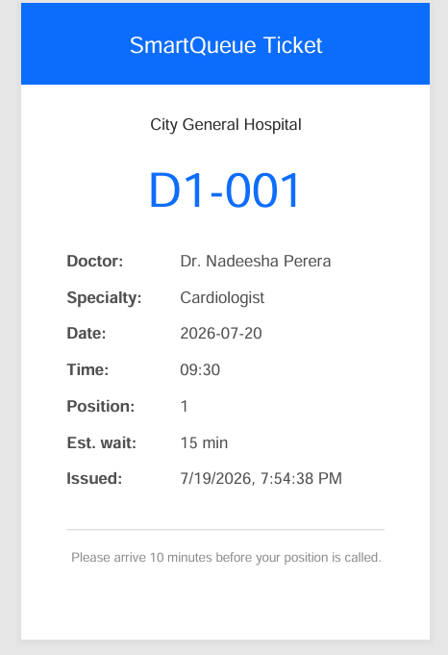
- Booking History

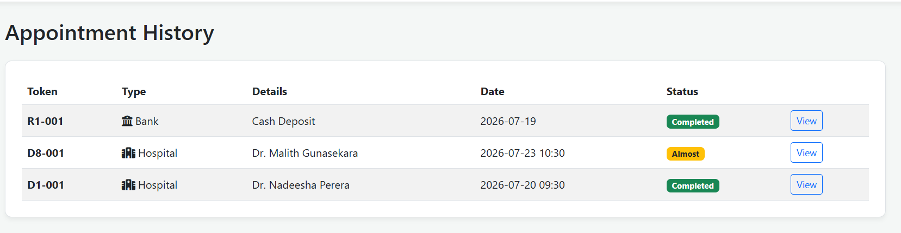

- User Profile
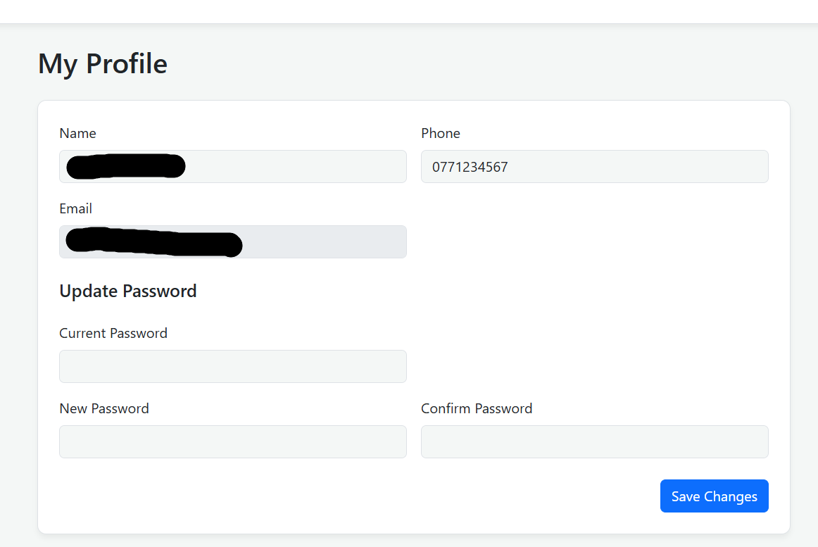

Admin Login

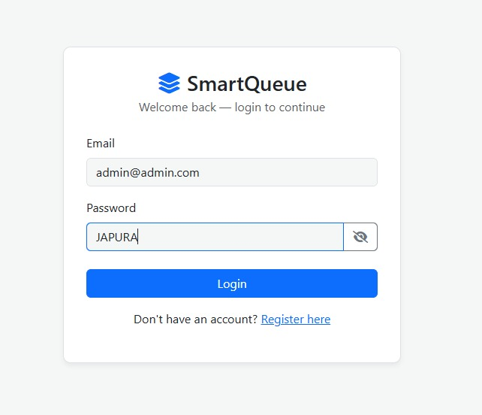

Admin Portal

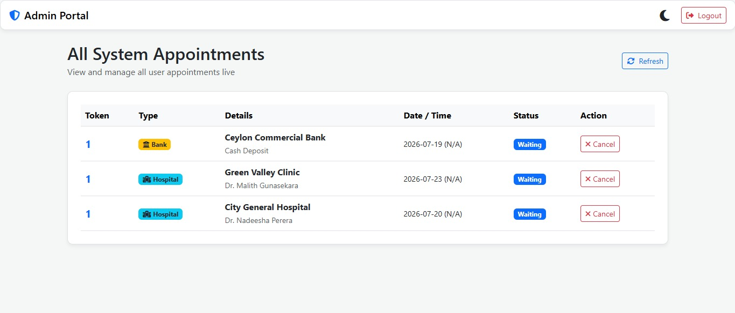

11. Testing
Test Case | Expected Result | Status
User Registration | New account created | Passed
User Login | Login successful | Passed
Book Appointment | Appointment created | Passed
Queue Generation | Queue number assigned | Passed
View Queue | Queue displayed | Passed
View History | Booking history shown | Passed
Logout | Session terminated | Passed

12. Future Improvements
Future enhancements include:
- MySQL database integration
- Java Spring Boot backend
- Email notifications
- SMS reminders
- QR code tickets
- AI-based waiting time prediction
- Mobile application (Android & iOS)
- Online payment integration
- Admin analytics dashboard
- Real-time queue updates using WebSockets

13. Conclusion
The Smart Queue Appointment System successfully addresses the inefficiencies of traditional queue management by providing a web-based digital solution. Users can conveniently register, book appointments, receive queue numbers, monitor queue status, and access booking history. The project demonstrates the effective use of Object-Oriented Programming principles, modern web technologies, and modular system design, making it scalable for future enhancements and suitable for real-world deployment.

14. References
- Oracle Java Documentation
- MDN Web Docs (HTML, CSS, JavaScript)
- Node.js Documentation
- GitHub Documentation
- REST API Design Guidelines

